# CS 255 System Design Document Template

## UML Diagrams

<https://drive.google.com/drive/folders/19fhTl7WjzyiSKVM8klSCgp90DAD9JM4m?usp=sharing>

### UML Use Case Diagram

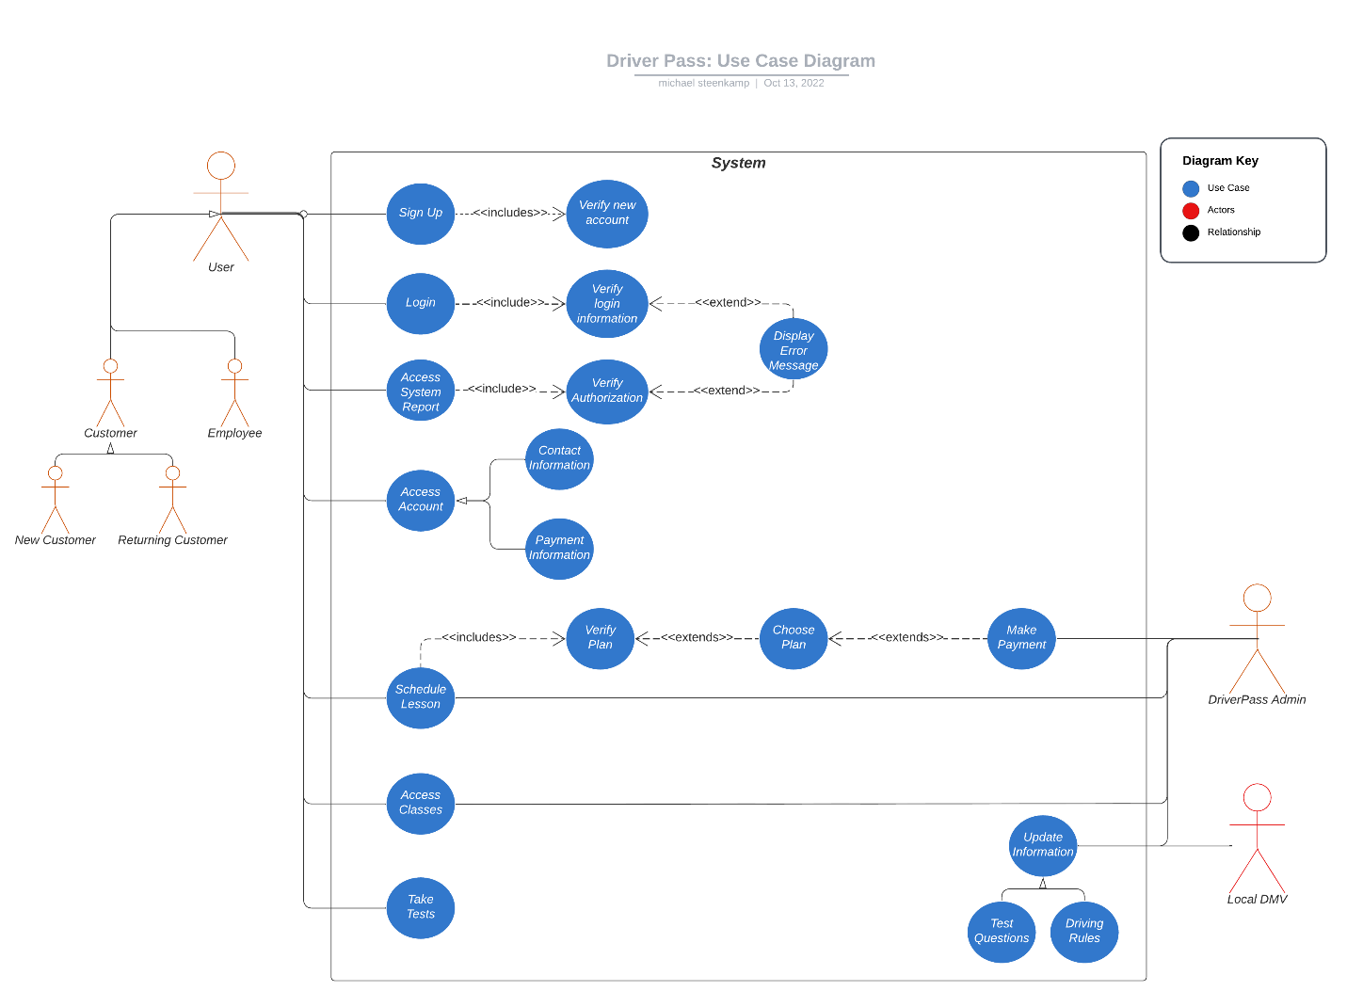

<https://drive.google.com/file/d/1CGrkjdB6O_jFLgECzCbGjUQ6Fu04WGXa/view?usp=sharing>

### UML Activity Diagrams

*Sign up*

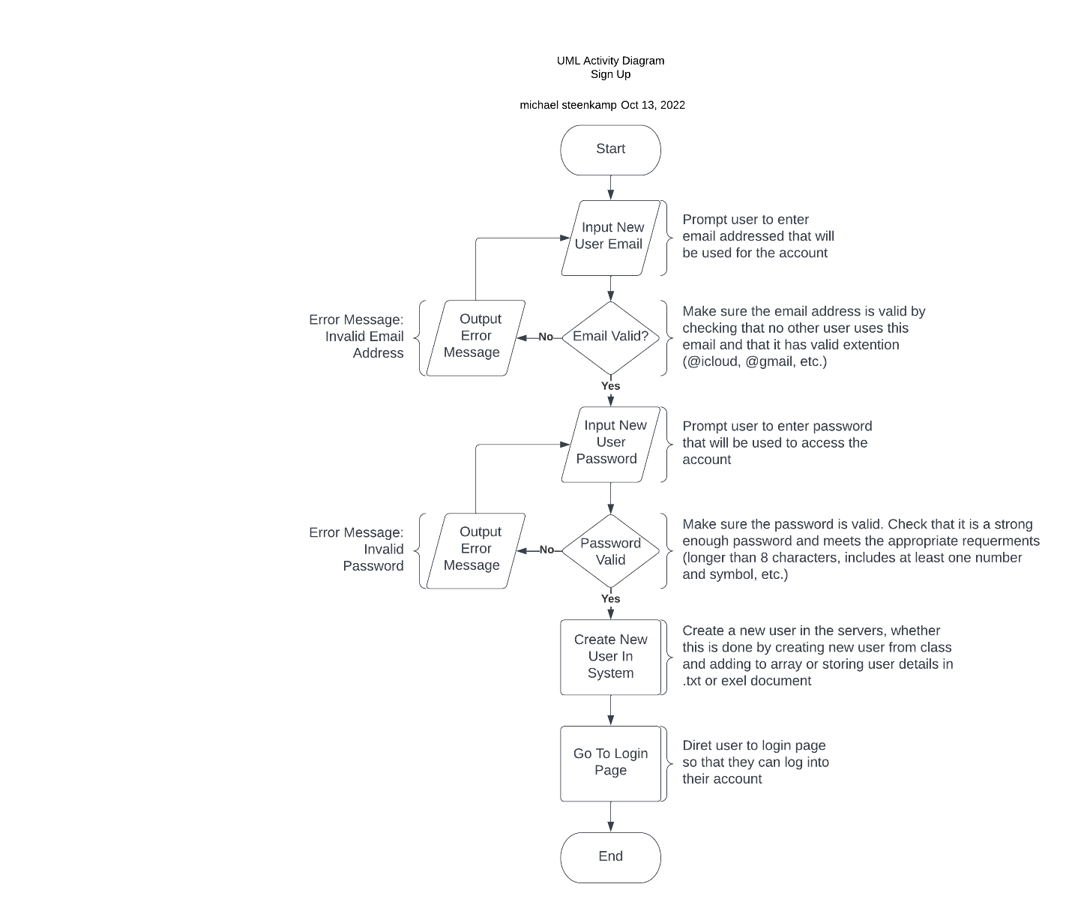

[*https://drive.google.com/file/d/1PoV_9x1mx7WFCmAam6ViK0xUdZjYxCBj/view?usp=sharing*](https://drive.google.com/file/d/1PoV_9x1mx7WFCmAam6ViK0xUdZjYxCBj/view?usp=sharing)

### UML Activity Diagrams

*Log in*

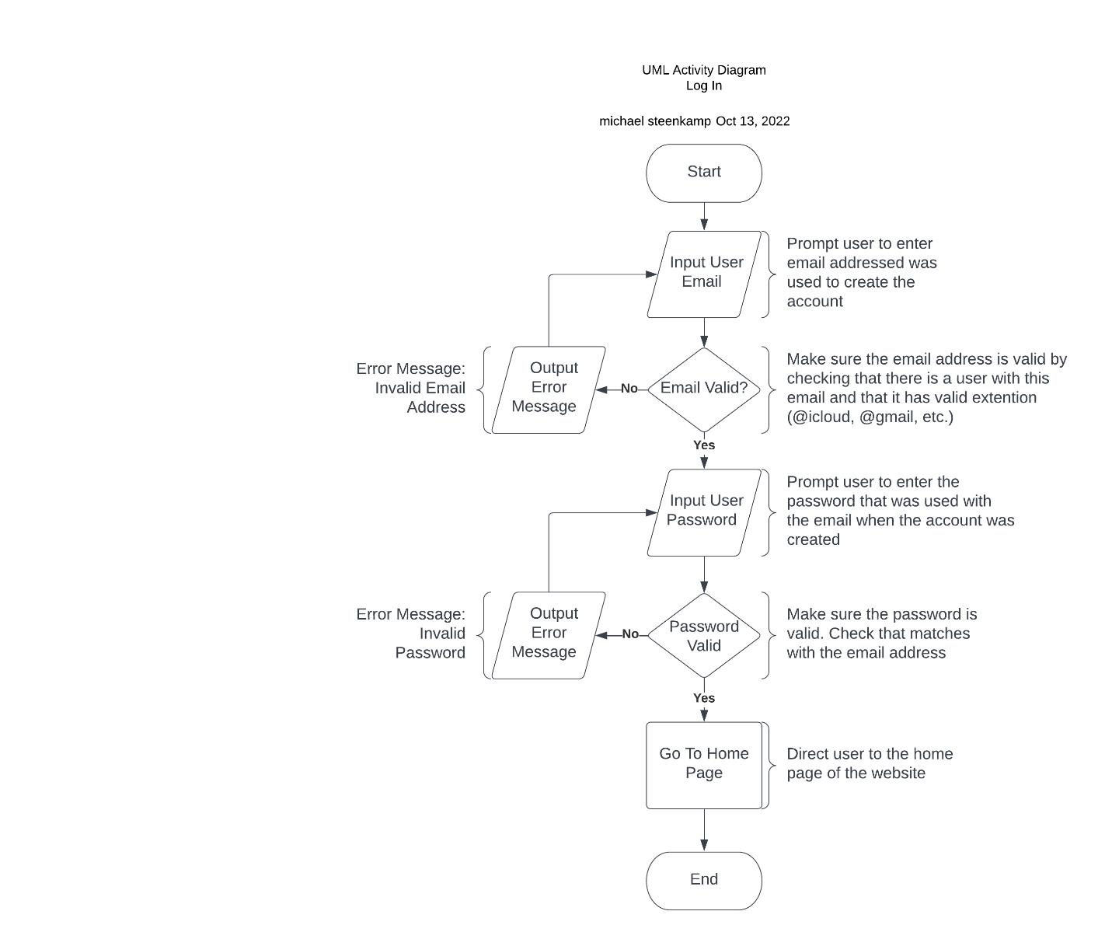

[*https://drive.google.com/file/d/1JNRHmuptlVpFx4L23Z_DCTG9Plw81O1X/view?usp=sharing*](https://drive.google.com/file/d/1JNRHmuptlVpFx4L23Z_DCTG9Plw81O1X/view?usp=sharing)

### UML Sequence Diagram

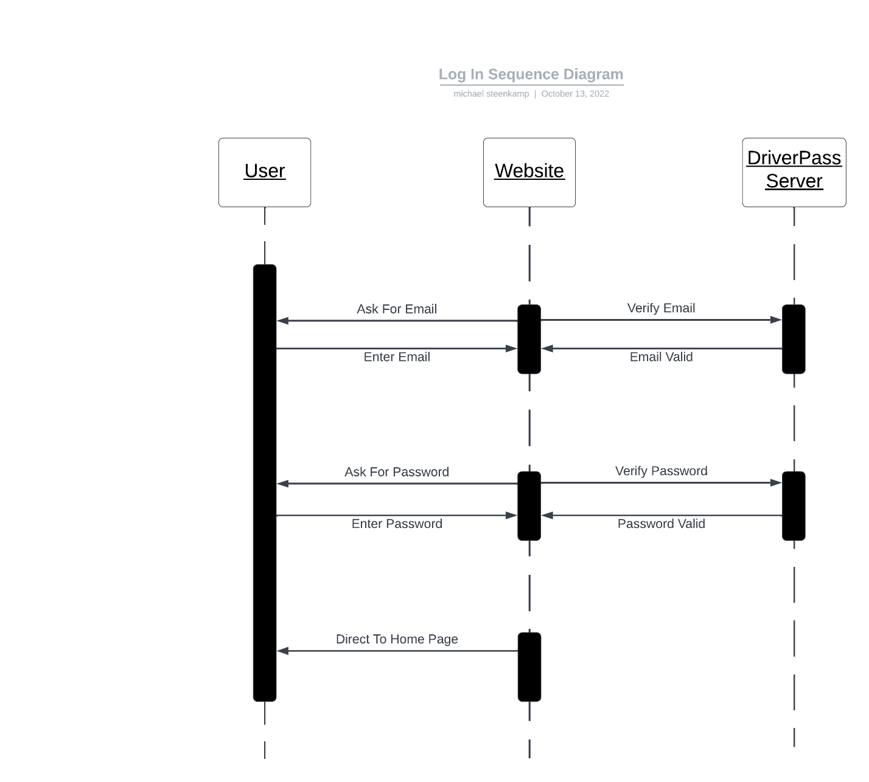

<https://drive.google.com/file/d/1rY5Zp_mTN7FpdQ9LutEi7dmOP6tyW2el/view?usp=sharing>

### UML Class Diagram

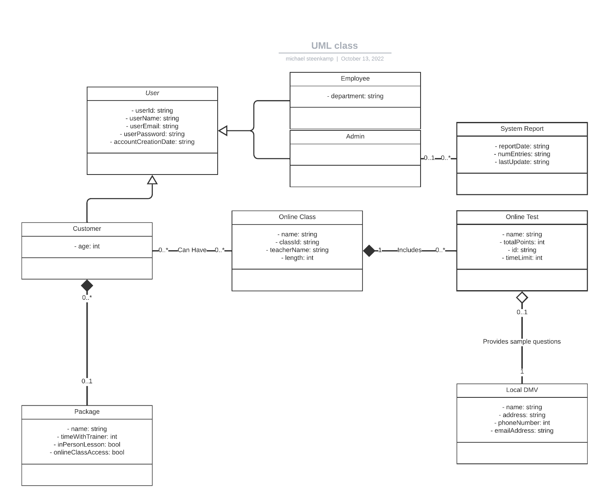

<https://drive.google.com/file/d/1AoELTnd4zuh1L5ile8vZWnWgErNorLg1/view?usp=sharing>

## Technical Requirements

The systems technical requirements include:

* A server that will be used to run the website
* A designated server storage to store server data such as user information
* A Linux based program written in JavaScript and/or HTML to host and manage the website
* A tool, such as an API, is required so that the system can communicate with the local DMV, etc.
* A security infrastructure is necessary to keep all private data secure.
* A sign up and login page is required
* A home page that includes links to various areas such as user profile, classes, upcoming tests, driving lessons, notes, etc. is required
* A system for users to connect with support services is required
* The system needs to follow an OOP infrastructure with hierarchy and parent-child classes.